Communications Plan Project Deadline: _September 30, 2018

Project Name: __Hep A awareness_____________ Start Date: ___June 6, 2018_________
Project Coordinator(s):___Kristina, Helen, Tamara, Sue, Cindy, Julie_____________________
OCDPH Section:
Community Health Clinical Services Environ. Health Epidemi. Other
MIHP Immuniz. Food Svc ____________________________________
Child Health CD On-site
Oral Health Sex Health Solid Waste ____________________________________
Health Promo

Budget: ____~$5,000_______________________________________________________________
Grant Requirements: ____Hep A messaging___________________________________________
COM Description:
Timing: Proactive Reactive Type: Inform for Decision Persuade for Change
Target Audience:
Internal: Staff Administration County-wide __________________________________________
External: Parents Youth General Community Media Policymaker _ High risk _________(MSM, drug users, transient/homeless, recent jail/prison, underlying liver disease)___________
Demographics: Age:_25-55__ Gender: _Male_ Culture: __high-risk___ Language: __English_____
Region: _Holland, Allendale, Hudsonville, Georgetown_______ Preferred COM method: __In-person, social media, print
Problem to Address: __Continued Hep A outbreak across the state resulting in hospitalizations and death. __Low public awareness of outbreak, seriousness of Hep A and how to prevent it. _____________
Desired Outcome(s): Behavior Change Awareness Prevention Policy Change Desired Action/Response:___Wash hands and get vaccinated__________________________________
Potential Barriers or Special Needs: ___Reaching homeless/transient populations via paid advertising – will need information in person _________________________________________________
Data/Research: (Reports, Surveys, Rankings, Numeric Analogy, Case Studies, Focus Groups or Visual Stats) __www.michigan.gov/HepAoutbreak / https://www.michigan.gov/mdhhs/0,5885,7-339-71550_2955_2976_82305_82310-447907--,00.html ________________________________________________ __https://www.cdc.gov/hepatitis/hav/afaq.htm _______________________________________________
Partners: (schools, advocacy groups, policymakers, religious org, healthcare org, specialist, community org, businesses) _____MDHHS and other LHDs for shared resources ___________________________________________
Key Message(s):
Stop the MI Hepatitis A outbreak
Wash your Hands
Get Vaccinated

Additional Notes & Resources: (existing promo material, personal/success stories, quotes, images/photos, analogies/metaphors, word clusters, infographics, etc.)

Develop consistent theme/look across all deliverables (colors, fonts, photos/graphics).
Share finalized assets with MDHHS and MiPIO Network.

Marketing Schedule

Phase | Date | Description | Deadline  Date | Hours worked on project
Develop COM plan | June 6 | Met with team to determine budget, select outreach options based on target audience | -
Review 1st Proof(s) | June 12 | Sent concept to team for review | June 14
Review 2nd Proof(s) | ongoing |  | ongoing
Review 3rd Final Proof(s)
Wrap-up/Evaluation |  |  | Sept 30

Deliverables | Budget | Assigned to | Target Delivery Date | Notes | Completed
GovDelivery email bulletin | 0 | KW | Aug & Sept | Send to relevant subscribers
News Release/PSA/Op-Ed | 0 | KW | TBD
miOttawa Website | 0 | KW | Done | Hot Topics – CDC microsite **Pull analytics | X
Social Media Ads | $1,250 | KW | Aug-Sept | Facebook/Instagram  Google/YouTube | X
Online Blogs or Comments
Online Event Calendars | 0 | CB | TBD | Post on-site clinic dates
Radio Appearances
TV Appearances
Paid TV Ads
Paid Radio Ads
Paid Print Ads | $210 | KW | July 17 | ¼ page ads in Revue magazine (Aug & Sept) | X
 | $750 | KW | July-Sept | Johnny Ads (Ottawa County only in bars/restaurants, men’s restrooms) | X
Postcards/Coupons | 0 | KW | TBD | Print in house (or get printer quotes)
White/Fact Sheets
Pamphlet/Brochure
Posters/Flyers/Rack Cards | 0 | KW | July | Create printable/sharable for bulletins and clinics | X
Banners
Promo Products
Signage | $1,520 | KW | July-Sept | Max Bus (4 interior and 3 exterior boards - 3 months, includes printing cost) | X
Billboards | $1,480 | KW | June-Aug | Lamar (2 boards – 4 weeks each) | X
Presentations & Conferences
Infographic | 0 | KW | July | Updated MDHHS to match campaign | X
Video Production (YouTube) | 0 | KW | July | Create 15sec video for social media ads and lobby tv | X
Audio Recording (podcast)
Administrator’s Digest
Community Resource 2-1-1 | 0 | KW | June | Updated with info on where to get Hep A vaccine | X
Other
TOTAL | ~$5,210
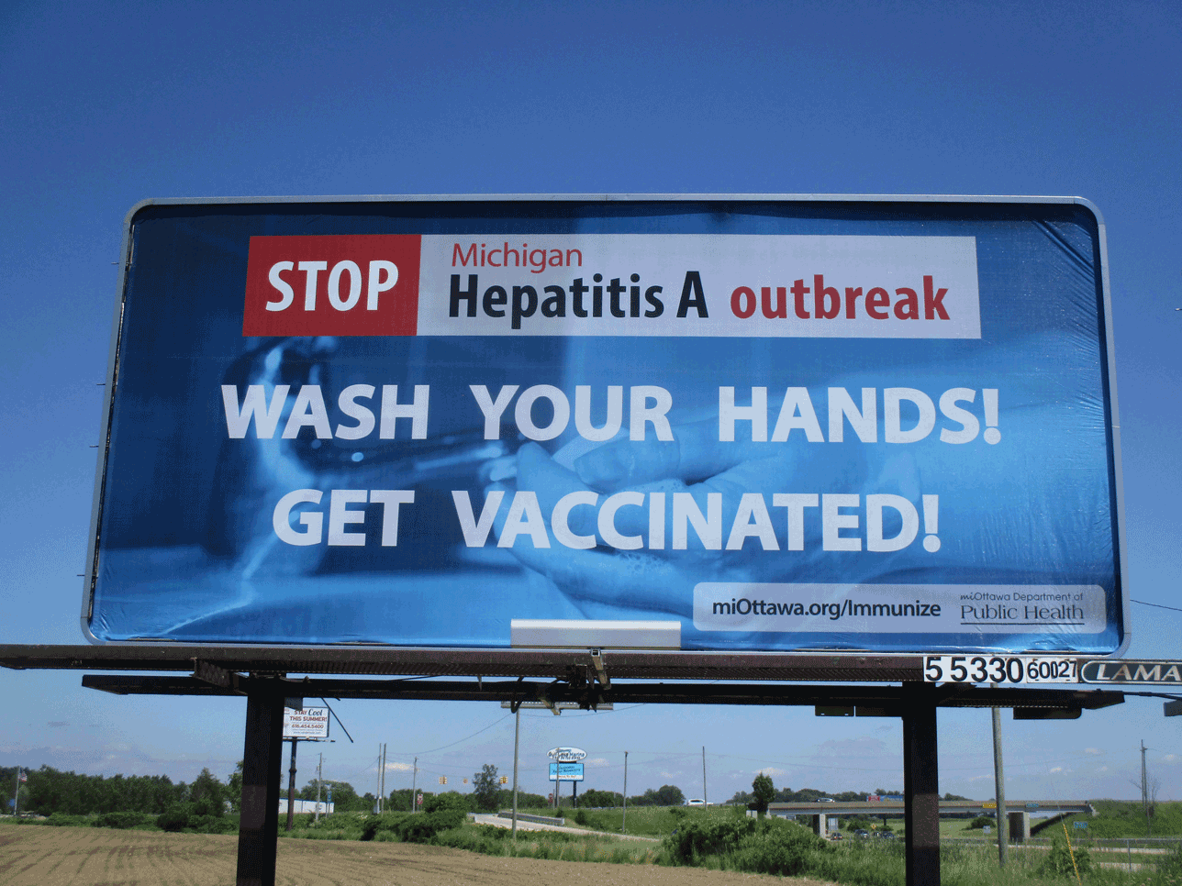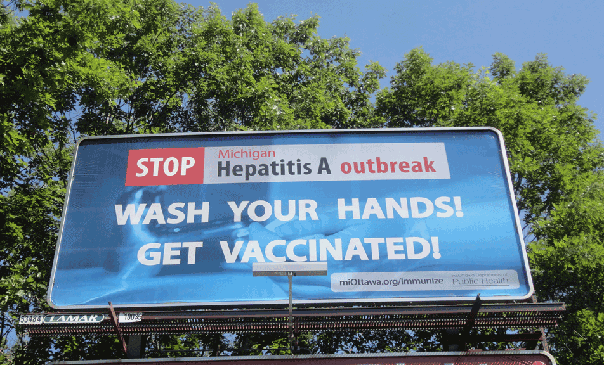

15 second video - https://youtu.be/SKWS5t9wKGM

