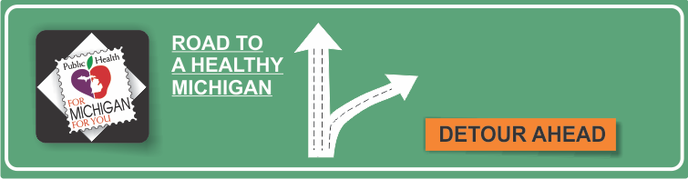[](http://www.countyhealthrankings.org)

* Alcohol is a psychoactive drug that has a depressant effect.
* Alcohol, consumed across cultures, often used to help and promote social interaction, is popular, generally accepted and legal.
* Alcohol is the most commonly used addictive substance in the United States- 17.6 million people, or one in every 12 adults, suffer from alcohol abuse or dependence.
* Excessive alcohol use, including underage drinking and binge drinking (drinking 5 or more drinks on a single occasion for men or 4 or more drinks on an occasion for women), can increase a person’s risk of developing serious health problems, including brain and liver damage, heart disease, and hypertension.
* Alcohol can disrupt fetal development at any stage during a pregnancy – including at the earliest stages and before a woman knows she is pregnant. Research shows that binge drinking, which means consuming four or more drinks per occasion, and regular heavy drinking put a fetus at the greatest risk for severe problems.

**Recognizing Public Health Month**

**Alcohol**

**Information Resources:**

**INSERT LOCAL HEALTH DEPARTMENT INFORMATION HERE**

National Council on Alcohol and Drug Dependence

[www.NCADD.org](http://www.NCADD.org)

Substance Abuse and Mental Health Services Administration

[www.samhsa.gov/atod/alcohol](http://www.samhsa.gov/atod/alcohol)

National Institute of Health

[www.nih.gov](http://www.nih.gov)

National Institute on Alcohol Abuse and Alcoholism

[www.niaaa.nih.gov](http://www.niaaa.nih.gov)

# Facts:

A few mild symptoms — which you might not see as trouble signs — can signal the start of a drinking problem. It helps to know the signs so you can make a change early. You might have a problem if you:

* Often drink more, or longer, than you intended.
* Have tried to cut down or stop drinking, but couldn’t.
* Have gotten yourself into risky situations during or after drinking.
* Spend a lot of time drinking or being sick after drinking.
* Have to drink much more than you once did to get the effect you want.
* Have memory blackouts when drinking.
* Continue to drink even though it causes trouble with family or friends.
* Find that drinking or being sick from drinking often interferes with taking care of your home, family, work or school.
* Give up or cut back on activities that were important or interesting to you in order to drink.
* Have gotten in trouble with the law or had legal problems because of your drinking.

Professional substance abuse counseling is available throughout Michigan. Contact your local Regional Entity for more information on services available in your area.

**Available Services:**

[Michigan Office of Recovery Oriented Systems of Care](http://www.michigan.gov/mdhhs/0,5885,7-339-71550_2941_4871_4877---,00.html)

Alcoholics Anonymous

[www.aa.org](http://www.aa.org)

Michigan Association of Community Mental Health Boards

[www.macmhb.org](http://www.macmhb.org)