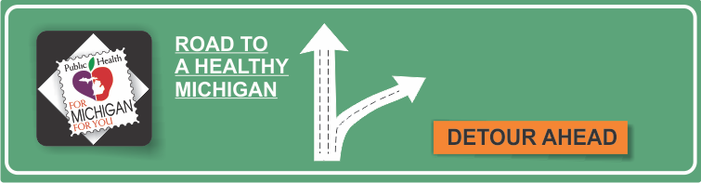[](http://www.countyhealthrankings.org)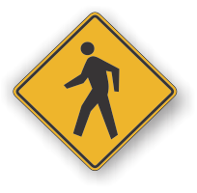

**INSERT LOCAL HEALTH DEPARTMENT INFORMATION HERE**

[National Diabetes Education Program](http://www.cdc.gov/diabetes/ndep/index.tm)

[American Diabetes Association](http://www.diabetes/org)

[Juvenile Diabetes Research Foundation](http://www.jdrf.org)

[National Diabetes Information Clearinghouse](http://diabetes.niddk.nih.gov/index.htm)

**Reduce Your Risks Month**

**Information Resources:**

**Diabetes**

* Diabetes is a disease in which blood glucose levels are above normal. Most of the food we eat is turned into glucose, or sugar, for our bodies to use for energy. The pancreas, an organ that lies near the stomach, makes a hormone called insulin to help glucose get into the cells of our bodies. When you have diabetes, your body either doesn't make enough insulin or can't use its own insulin as well as it should. This causes sugar to build up in your blood.
* Diabetes can cause serious health complications including heart disease, blindness, kidney failure, and lower-extremity amputations. Diabetes is the sixth leading cause of death in the United States.
* People who think they might have diabetes must visit a physician for diagnosis. They might have SOME or NONE of the following symptoms: Frequent urination * Excessive thirst * Unexplained weight loss * Extreme hunger * Sudden vision changes * Tingling or numbness in hands or feet * Very tired most of the time * Very dry skin * Sores that are slow to heal*
* Nausea, vomiting, or stomach pains may accompany some of these symptoms in the abrupt onset of insulin-dependent diabetes, now called Type 1 diabetes. Healthy eating, physical activity, and insulin injections are the basic therapies for Type 1 diabetes.
* Healthy eating, physical activity, and blood glucose testing are the basic therapies for Type 2 diabetes. In addition, many people with Type 2 diabetes require oral medication, insulin, or both to control their blood glucose levels.
* People with diabetes must take responsibility for their day-to-day care, and keep blood glucose levels from going too low or too high. People with diabetes should see a health care provider who will monitor their diabetes control and help them learn to manage their diabetes. In addition, people with diabetes may see endocrinologists, who may specialize in diabetes care; ophthalmologists for eye examinations; podiatrists for routine foot care; and dietitians and diabetes educators who teach the skills needed for daily diabetes management.

# Facts:

**Available Services:**

What services are available either locally or statewide?

Can add hyperlinks here too!

**Risk Factors for Development of Diabetes**

* Being overweight or obese.
* Having a parent, brother, or sister with diabetes.
* Being African American, American Indian, Asian American, Pacific Islander, or Hispanic American/Latino heritage.
* Having a prior history of gestational diabetes or birth of at least one baby weighing more than 9 pounds.
* Having high blood pressure measuring 140/90 or higher.
* Having abnormal cholesterol with HDL ("good") cholesterol is 35 or lower, or triglyceride level is 250 or higher.
* Being physically inactive—exercising fewer than three times a week.