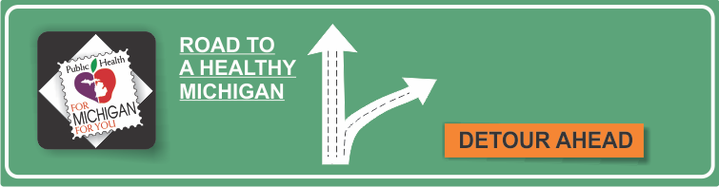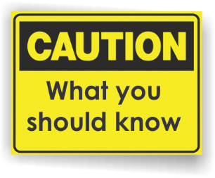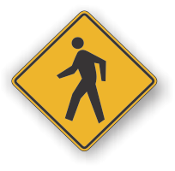[](http://www.countyhealthrankings.org)

**Information Resources:**

* In 2013, 34.6% of Michigan adults reported ever being told they have high blood pressure (HBP).
* Even more significant, of all individuals with high blood pressure, only   
  one-third of them have their blood pressure under control.
* High blood pressure makes the heart work harder than normal. This increases the chance of heart disease.
* Uncontrolled high blood pressure can lead to stroke, heart attack, heart failure, or kidney failure.
* High blood pressure is often called the “silent killer” because most people with high blood pressure have no signs or symptoms, even if blood pressure readings reach dangerously high levels.
* By 2030, heart disease cases in Michigan are projected to rise from 600,000 to 2.9 million.
* More than 25% of deaths in Michigan in 2013 were due to cardiovascular disease and stroke.
* Normal blood pressure is less than 120/80 mm Hg. Readings above 140 and/or 90 mm Hg are considered high.

# Facts:

**Blood Pressure**

**{INSERT LOCAL HEALTH DEPARTMENT CONTACT INFORMATION}**

**American Heart Association**

[www.heart.org](http://www.heart.org)

**Centers for Disease Control and Prevention**

[www.cdc.gov/heartdisease](http://www.cdc.gov/heartdisease)

**Go Red for Women**

[www.goredforwomen.org](http://www.goredforwomen.org)

**Michigan Department of Health and Human Services**

[www.michigan.gov/cvh](http://www.michigan.gov/cvh)

**National Heart, Lung, and Blood Institute**

[www.nhlbi.org](http://www.nhlbi.org)

**Healthy Hearts Month**

**Additional Information:**

**PREVENTION AND TREATMENT STRATEGIES:**

Lifestyle changes can help you control and prevent high blood pressure – even if you are taking blood pressure medication. Here’s what you can do:

* Eat a healthy diet. Follow the DASH diet, which includes lots of fruits and vegetables, limited salt, low fat dairy products, low cholesterol, low saturated fats, and good intake of calcium, potassium, and magnesium.
* Increase physical activity.
* Get an annual examination.
* Limit alcohol.
* Don’t smoke.
* Take medications as prescribed and be involved in your ongoing care.
* Reduce stress factors.

**RISK FACTORS:**

High blood pressure has many risk factors. Some you can’t control.

* **Age.** The risk of high blood pressure increases as you get older. Through early middle age, high blood pressure is more common in men. Women are more likely to develop high blood pressure after menopause.
* **Race.** High blood pressure is particularly common among blacks, often developing at an earlier age than it does in whites. Serious complications, such as stroke and heart attack, also are more common in blacks.
* **Family history.** High blood pressure tends to run in families.

Other risk factors for high blood pressure are within your control.

* **Excess weight.** The more you weigh the more blood you need to supply oxygen and nutrients to your tissues. As the volume of blood circulated through your blood vessels increases, so does the pressure on your artery walls.
* **Inactivity.** People who are inactive tend to have higher heart rates. The higher your heart rate, the harder your heart must work with each contraction – and the stronger the force on your arteries. Lack of physical activity also increases the risk of being overweight.
* **Tobacco use.** The chemicals in tobacco can damage the lining of your artery walls, which promotes narrowing of the arteries.
* **Sodium intake.** Too much sodium or salt in your diet – especially if you have sodium sensitivity – can lead to fluid retention and increased blood pressure.
* **Low potassium intake.** Potassium helps balance the amount of sodium in your cells. If you don’t consume or retain enough potassium, you may accumulate too much sodium in your blood.
* **Excessive alcohol.** Over time, heavy drinking can damage your heart.
* **Stress.** High levels of stress can lead to a temporary but dramatic increase in blood pressure. If you try to relax by eating more, using tobacco, or drinking alcohol, you may only fuel problems with high blood pressure.