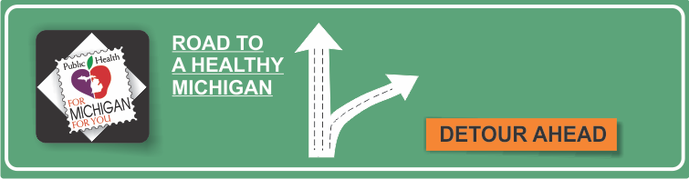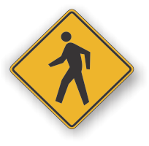[](http://www.countyhealthrankings.org)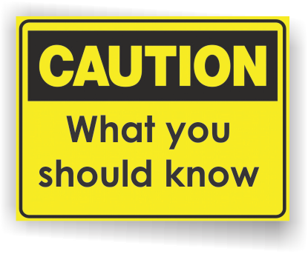

**Women & Heart Disease**

* Cardiovascular diseases cause one in three women’s deaths each year, killing approximately one woman every minute.
* One in 2.6 women will die of heart disease or stroke, compared with one in 30 from breast cancer.
* Heart disease, stroke, and other cardiovascular diseases are the number one killer in Michigan.
* Almost two-thirds of women who die suddenly of coronary heart disease have no previous symptoms.
* Regular screening for high blood pressure, diabetes, high cholesterol, and overweight can help you take early action to control these risks.
* Know your family history for heart disease and associated risk factors. If your father or brother had a heart attack before age 55, or your mother or sister before age 65, you are at a higher risk of heart disease.

**INSERT LOCAL HEALTH DEPARTMENT INFORMATION**

**American Heart Association**

[www.heart.org](http://www.heart.org)

**Centers for Disease Control and Prevention**

[www.cdc.gov/heartdisease](http://www.cdc.gov/heartdisease)

**Go Red for Women**

[www.goredforwomen.org](http://www.goredforwomen.org)

**Michigan Department of Health and Human Services**

[www.michigan.gov/cvh](http://www.michigan.gov/cvh)

**National Heart, Lung, and Blood Institute – The Heart Truth**

[www.nhlbi.nih.gov/health/hearttruth](http://www.nhlbi.nih.gov/health/hearttruth)

**Healthy Hearts Month**

**Information Resources:**

# Facts:

Women often do not have the “classic” heart attack symptoms. The symptoms may be mild and different than those experienced by men.

Women need to know these heart attack signs and symptoms:

* Pain or discomfort in the center of the chest that lasts more than a few minutes, or goes away and comes back. It might feel like an uncomfortable pressure, squeezing, fullness, or pain.
* Pain or discomfort in other areas of the upper body, including the arms, back, neck, jaw, or stomach.
* Other symptoms such as shortness of breath, breaking out in a cold sweat, nausea, or light-headedness.
* Women more than men experience shortness of breath, nausea/vomiting, flu-like symptoms, fatigue, and back or pain radiating to jaw, left arm, or shoulder.

**Don’t wait until it’s too late! This is a matter of life and death!** If you experience any of these symptoms, call for help within five minutes. Not wanting to be embarrassed or cause false alarm can be a fatal mistake.

**Call 9-1-1 even if you aren’t sure you are having a heart attack!** Many heart attack victims die before they get to the hospital. Calling emergency medical services (EMS) can be lifesaving. EMS personnel can provide life-saving treatment as soon as they arrive. If EMS isn’t available,

have someone else drive you to the hospital.

**Don’t smoke, and if you do, quit.** Women who smoke are two to six times more likely to suffer a heart attack than non-smoking women. Smoking also boosts the risk of stroke and cancer.

**Aim for a healthy weight.**  It’s important for a long, vigorous life. Overweight and obesity cause many preventable deaths.

**Get moving.** Make a commitment to be more physically active. Aim for 30 minutes of moderate-intensity activity on most, preferably all, days of the week.

**Eat for heart health.**  Choose a diet low in saturated fat, trans fat, and cholesterol, and moderate in total fat.

**Know your numbers.** Ask your doctor to check your blood pressure, cholesterol (total, HDL, LDL, triglycerides), and blood glucose. Work with your doctor to improve any numbers that are not normal.

**Tips for Heart Health:**