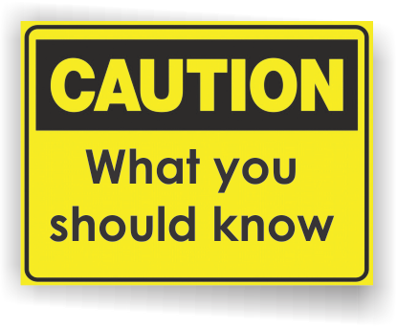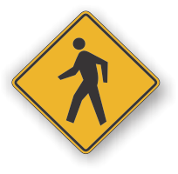[](http://www.countyhealthrankings.org)

Your local health department works to protect the health of consumers by assuring that the food prepared and served at county licensed food service establishments is safe to eat. They do this by:

* Make licensing recommendations to the Michigan Department of Agriculture
* Conduct regulatory inspections at all licensed food service establishments
* Provide food safety education for food service owners, managers, and staff
* Assuring that management level food service staff is highly trained and certified in food safety
* Investigate and identify sources of foodborne illness complaints

The Michigan Department of Agriculture and Rural Development (MDARD) licenses and inspects over 19,000 grocery and convenience stores, food processors and food warehouses. Routine inspections are conducted at a 6, 12 or 18 month frequency depending on the type and complexity of food handling. Restaurants are inspected by local health departments.

The US Food and Drug Administration (FDA) regulates dietary supplements, bottled water, food additives, infant formulas and food products other than meat, poultry, and egg products. The US Department of Agriculture (USDA) is responsible for enforcement of most regulations relating to meat, poultry, and egg products. The USDA also inspects domestic product imports and exports, conducting risk assessments, and educating the public about food safety.

**Information Resources:**

INSERT YOUR LOCAL HEALTH DEPARTMENT INFORMATION HERE

**Michigan Department of Agriculture**

[www.michigan.gov/mdard](http://www.michigan.gov/mdard)

**United States Department of Agriculture**

[www.fsis.usda.gov](http://www.fsis.usda.gov)

**US Food and Drug Administration**

**Food Protection Plan**

[www.fda.gov/food](http://www.fda.gov/oc/initiatives/advance/food.html)

**Federal Food Safety Information**   
[www.foodsafety.gov](http://www.foodsafety.gov)

# Facts:

**FOOD SUPPLY**

**SAFETY**

**FOOD SAFETY MONTH**

**Available Services:**

**Food shopping**

* Purchase refrigerated or frozen items after selecting your nonperishables.
* Never choose meat or poultry in packaging that is torn or leaking.
* Do not buy food past "Sell-By," "Use-By," or other expiration dates.
* Check safety seals and report damaged or tampered items to store managers.
* Avoid buying cans that are deeply dented, bulging, or have a dent on either the top or side seam.
* Put raw meat, poultry, and seafood in plastic bags before placing them in your cart.
* When checking out, place raw meat, poultry and seafood in separate bags from ready-to-eat foods.

**Food Storage**

* To keep bacteria in check, refrigerators should run at 40 degrees Fahrenheit and freezers at 0 degrees Fahrenheit. Generally, keep your refrigerator as cold as possible without freezing milk or lettuce.
* If you do not use fresh meat, poultry or fish immediately, wrap it well and put it in the freezer.
* Packages of raw meat, poultry or fish should be wrapped well enough (zip-lock bags work great) so juices do not drip onto other food in the refrigerator or freezer.
* Keep non-perishables in "dry, high" places away from pests and dampness.
* When in doubt, throw it out!
* When you cook ahead of time, divide large portions of food into small, shallow containers for refrigeration. The key is safe, rapid cooling to prevent the growth of bacteria.

**Preparing for a possible weather emergency**

* Keep a thermometer in the refrigerator and freezer in case of a power outage.
* Freeze containers of water ahead of time for ice to help keep foods cold in the freezer, refrigerator or coolers after the power is out.
* Freeze refrigerated items such as leftovers, milk and fresh meat and poultry. This helps keep them at a safe temperature longer.
* Group foods together in the freezer. Foods will stay cold longer.

**How to Keep Food Safe During an Emergency**

* Throw away food that may have come in contact with flood or storm water, perishable foods, and those with an unusual odor, color, or texture.
* Throw away perishable foods (including meat, poultry, fish, eggs, and leftovers) in your refrigerator when the power has been off 4 hours or more.
* Thawed food that contains ice crystals can be refrozen or cooked. Freezers, if left unopened and full, will keep food safe for 48 hours.
* During snowstorms, do not place perishables out in the snow. Outside temperatures vary and food can be exposed to unsanitary conditions and animals. Instead make ice with snow using buckets and empty containers. Put these containers in your freezer and refrigerator.

What services are available either locally or statewide?

You can add hyperlinks here too!