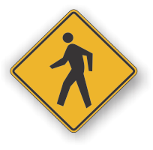[](http://www.countyhealthrankings.org)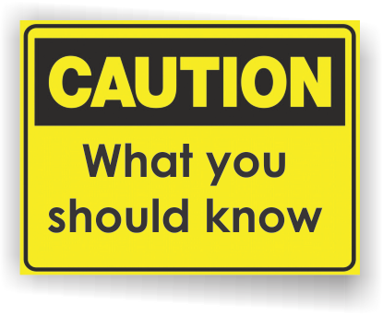

**Back to School Month**

**Vision Loss:**

**Children & Teens**

* Approximately 6.8% of children younger than 18 years in the United States have a diagnosed eye and vision condition.
* In the United States, the most common disabling childhood conditions are vision disorders.
* 80% of all visual impairment can be prevented or cured.
* Children usually do not know that they see differently. Early identification of an eye problem is important. Conditions like amblyopia, or lazy eye, can be prevented if detected and treated during pre-school years.

**INSERT LOCAL HEALTH DEPARTMENT CONTACT INFORMATION**

**Michigan Department of Health & Human Services**

*Vision screening*

[www.michigan.gov/mdhhs/0,5885,7-339-73971_4911_4912_6238-260487--,00.html](http://www.michigan.gov/mdhhs/0,5885,7-339-73971_4911_4912_6238-260487--,00.html)

**National Eye Institute**

*Eye health organizations list*

[www.nei.nih.gov/health/eye-health-organization-database](http://www.nei.nih.gov/health/eye-health-organization-database)

**Centers for Disease Control and Prevention**

*Vision Loss Fact Sheet*

[www.cdc.gov/ncbddd/actearly/pdf/parents_pdfs/VisionLossFactSheet.pdf](http://www.cdc.gov/ncbddd/actearly/pdf/parents_pdfs/VisionLossFactSheet.pdf)

**Information Resources:**

# Facts:

What services are available either locally or statewide?

Can add hyperlinks here too!

**What is vision loss?**

Vision loss means that a person’s eyesight cannot be fixed to a “normal” level, making it hard to do daily tasks without eyeglasses, contact lenses, or other help. Vision loss can vary among children and can be caused by many things. Vision loss can be caused by damage to the eye, by the eye being misshaped, or even a problem in the brain. Babies can be born unable to see, and vision loss can occur anytime during a person’s life.

**When should my child be checked?**

Your child should be checked for vision problems by an eye doctor (an ophthalmologist), pediatrician, or other trained specialist at:

* Newborn to 3 months
* Six months to 1 year
* About 3 years AND 5 years

**What are signs of vision loss?**

A child with vision loss might:

* Close or cover one eye
* Squint the eyes or frown
* Complain that things are blurry or hard to see
* Have trouble reading or doing other close-up work, or hold objects close to eyes to see
* Blink more than usual or seem cranky when doing close-up work (such as looking at books)

One eye of a child with vision loss could look out or cross. One or both eyes could be watery, and one or both of the child’s eyelids could also look red-rimmed, crusted, or swollen.

**If you think your child may have vision loss, speak to your doctor, nurse, or local health department right away.**

**Available Services:**