Certificate of Appreciation
awarded to

KND Brethren School
For allowing District Health Department #10 to hold a school-based immunization clinic in your school as part of the MALPH Sustaining Immunization Action Grant Initiative. Thank you, also, for helping us promote the event by sending out flyers, emails, and posting it at your schools.
Awarded this 10th day of November, 2017
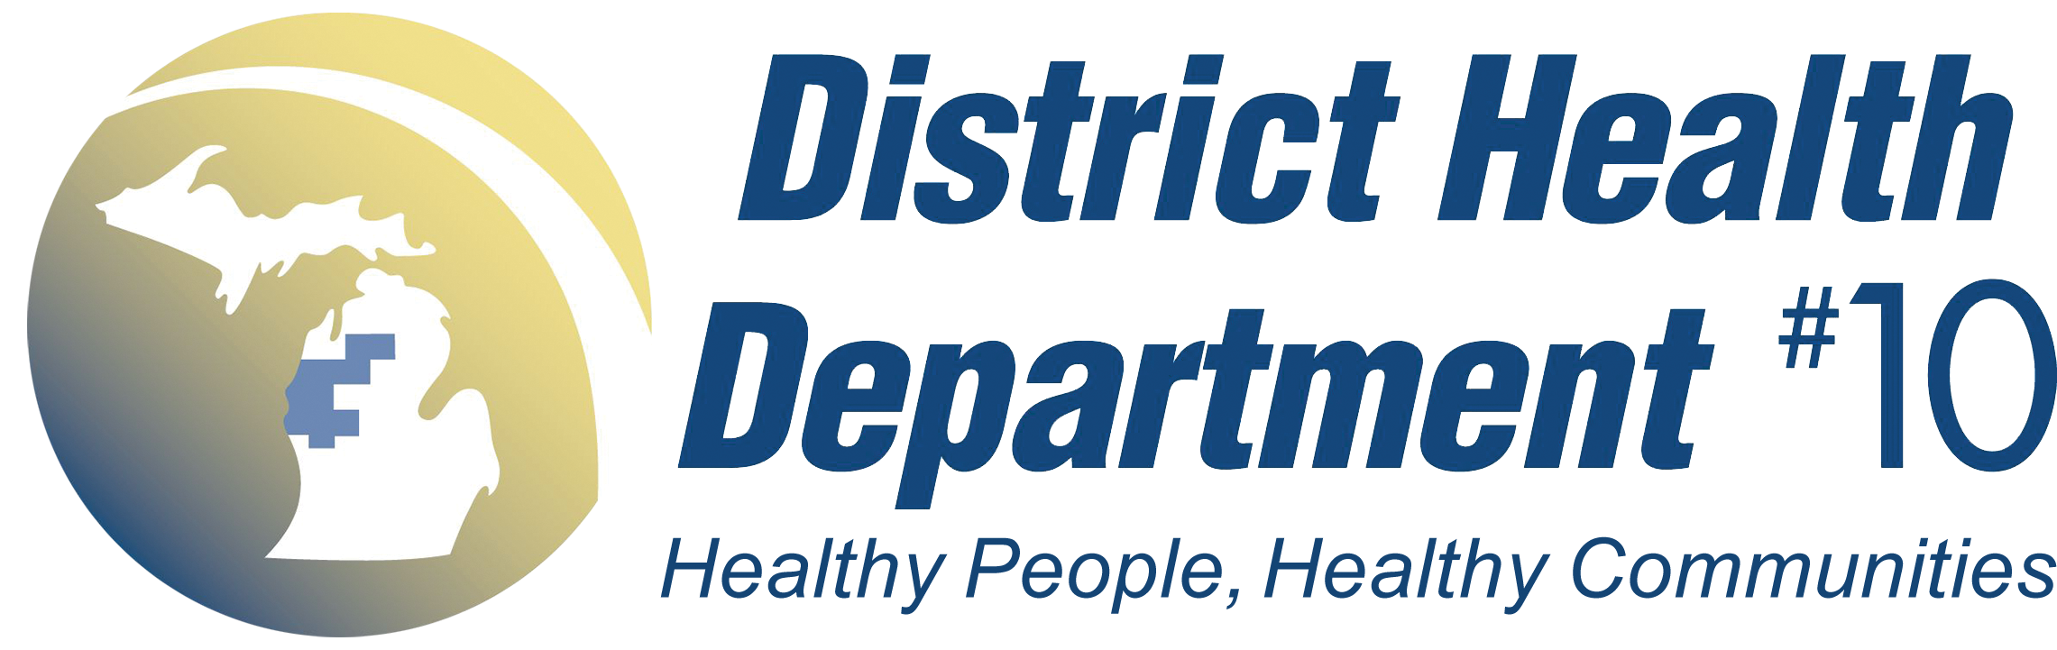
Robin Walicki BSN, RN
DHD#10 Immunization Program Coordinator

