A shot only takes a moment—the protection can last a lifetime…

Vaccines protect your family from many diseases. We want to make sure that your family is protected.

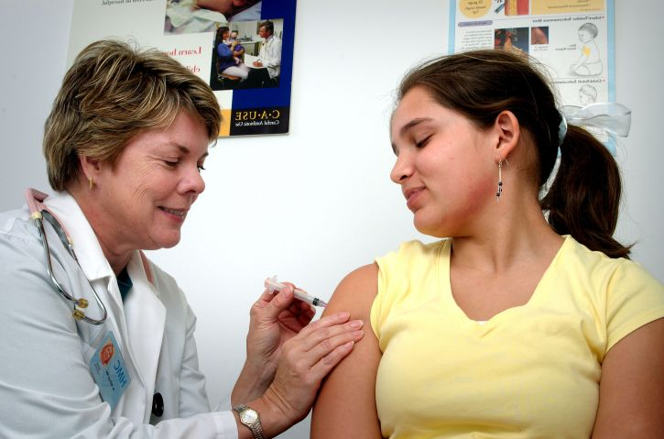
We have checked your child’s vaccine record and they are not up to date on all of their vaccines. This means they are not fully protected from disease.

You can help your child by scheduling an appointment today. Call your doctor or one of our offices to make that appointment.

We accept many insurances, and we offer shots for kids through the Vaccines for Children program. In the coming months, we will also be holding several special shot clinics in area schools, so stay tuned for more information!

To see which shots your child needs, please read the other form in this envelope. If you think we made a mistake and your child is up to date, just call us or your doctor and they will be happy to update your record.

If you have any questions please call us. We are always here to help you and your family stay healthy.

Sincerely,

Robin Walicki BSN, RN Deb Gullekson
Immunization Program Lead Immunization Clerk
DHD#10 DHD#10

RW 4/16

