Health Education and Promotion & Public Information Officer Forum
Staffing Status, Capacity, and Needs Survey
Executive Summary
In the spring of 2017 the Health Education and Promotion (HEP) and the Public Information Officer (PIO) Forums of MALPH developed and initiated a survey in an effort to better understand the current status of health education and public information personnel within local health departments (LHD). Prior capacity assessment surveys by MALPH covered health education and promotion as well as public information, but not detail. The HEP and PIO forums were more curious about the educational backgrounds and types of work personnel with a title similar to “health educator” and/or “PIO” were actually performing in LHDs. The information collected included number of FTEs, titles, educational backgrounds and certifications, program focus areas, salaries and funding sources, and personal qualities and skillsets. Twenty nine of the 45 LDHs responded to the survey. Average jurisdictional population was 196,329 persons with an average staff size of 97.4 persons. A majority of respondents classified their jurisdictions as rural (60%).

All responding LHDs had staff assigned to “health education” The number of FTEs assigned to health education was relational to LHD overall staffing size where the smallest LHDs had only an average of 1.85 FTEs dedicated to health education to the largest, with over 10 FTEs dedicated to health education and promotion. A number of titles were given to classified “health educators” and educational backgrounds/certifications varied widely. Only one third of health educators were funded through general fund/county dollars. Most salaries came from grants and/or special contracts. Average starting wage was $19.87 per hour. Many LHDs reported other staff such as sanitarians, nurses, administrative assistants, and PIOs as delivering health education and promotional services in their communities.

As well, all LDH respondents had designated PIO staff. Number of dedicated staff ranged from 1.3 FTE to 2.3 FTE at larger LHDs. Reportedly, these staff had a number of PIO duties, with only an average of 25% of their time dedicated to media and public information. Most communication dissemination occurred through forms of social media, email, and website postings .Educational backgrounds for PIOs varied widely as well as special certifications; however, all had specialized PIO training with exceptional training in Incident Command Systems (ICS). Average starting wage was $27.11 per hour with a top of the pay scale wage at $28.16 per hour. Just over half of responding LDHs had a communication or a branding plan and LDHs listed a wide variety of methods used to communicate their plans to the public. Most LHDs expressed interest in dedicating more time to media and public information, but cited lack of funding as a barrier.

Overall Response Detail
Response %: 29 of 45 or 64%
Responses received: February 16, 2017 to May 25, 2017

Participating LHDs:
Barry-Eaton District Health Department  Bay County Health Department  Benzie-Leelanau District Health Department  Berrien County Health Department  Calhoun County Public Health Department  Central Michigan District Health Department  Chippewa County Health Department  Delta Menominee Public Health  District Health Department #10  District Health Department No. 2  Huron County Health Department  Ingham County Health Department  Jackson County Health Department  Kalamazoo County Health & Community Services  Kent County Health Department |  |  |  |  |  | Lapeer County Health Department  Lenawee County Health Department  Livingston County Health Department  LMAS District Health Department  Midland County Health Department  Mid-Michigan District Health Department  Monroe County Health Department  Muskegon County, Public Health  Northwest Michigan, Health Department of  Oakland County Health Division  Ottawa County Public Health  Saginaw County Department of Public Health  Shiawassee County Health Department  St Clair County Health Department  Washtenaw County Public Health
Jurisdiction  Population: |  | Smallest: 33,801  Largest: 1,200,000  Average population: 196,329
Geographic: |  | Rural: 18  Suburban: 6  Urban: 6
Staff Size: |  | Smallest: 26  Largest:366  Average: 97.4  <= 50: 8  51 to 100: 15  >=101: 7
Health Education Focused Questions
Health Education Dedicated Staff (solely dedicated): |  |  |  |  | Average Number of Health Departments with:  <=50 total staff: 1.85  51 to 100 staff: 2.47  101 to 366 staff: 10.29
Titles of Dedicated HD Staff:  Titles containing the word  Community: 4  Coordinator: 5  Education/Educator: 4  Health Promotion: 3  Program: 2  Specialist: 4  Substance Abuse: 2 |  |  |  |  | 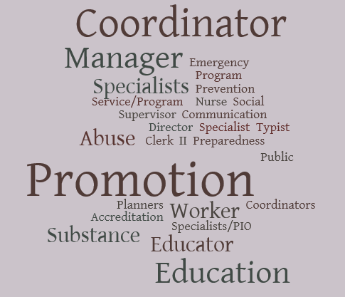
Educational Background of Health Education and Promotion Staff
Allied Health  Anthropology  Bachelors Social Work  Biology  BS Nursing  Communications  Community Health Education  Environmental Health  Epidemiology  Family Services and Studies  Fitness/Wellness |  |  |  |  |  |  | Health Behaviors  Health Equity  Health Promotion  Health Sciences (Masters and Bachelors)  Journalism  M. Ed  MPH Maternal Child Health  Phys Ed/Coaching  Spanish  Youth Development
BA, BBA, BS, MA, MPH, CPST, MHEPP, MSA, MSW, RDH, BSHP

Certifications: | LMSW, CHES, CPS-R, MCHES, ASECT, CPS, Wellness Practitioner, Passenger Safety Technician, Crisis Communications
Content Areas for Health Education and Promotion Staff
BCCCNP  CHNA/CHIP assistance  Chronic Disease/Diabetes  Communicable Disease = 14  Community Planning and Improvement = 19  Data Analysis  Emergency Preparedness  Environmental Health = 7  Fatherhood Initiative  Grant Focused work  Health Assessment/Needs Improvement  Immunizations  Improving Nutrition = 17  Increasing Physical Activity = 17  Infant Mortality Reduction = 9  Injury Prevention  Lead Poisoning  Maternal Child Health |  |  |  |  |  | Media/Social Media  Mental Health  Newsletter Development  Obesity Reduction = 17  Older Adult Health  Oral health  PHAB Accreditation = 7  PIO  Reproductive/Sexual Health  Safe Sleep  School-based health  Sexual Violence Prevention  Skin Cancer Prevention  STD reduction  Substance Abuse = 23  Teen Pregnancy Prevention = 12  Worksite Wellness
Health Educators double as CHW? |  |  |  |  | Yes 1  No 25
Health Educator Qualities
1-3 years minimum experience  Ability to work collaboratively  All CHES/MCHES core competencies  CHES or CPS certified  Commitment to Public Health  Communication skills  Community Health background  Community planning and evaluation  Critical thinker  Diverse skill sets  Education background |  |  |  |  |  | Flexible  Foundation in Health Promotion, design/marketing  Knowledge about community  Organizational skills  Passionate, Enthusiastic, Outgoing  Professional  Public speaking, facilitation, leadership  Self-starter  Strong writing skills, grant writing  Team player, collaborator  Translate complex concepts to clear language  Understanding of data
Salary/hr: |  |  | Average Starting Wage: $19.87  Average Top of Scale (not including supervisory pay): $26.36
Health Educator Funding: |  |  | Grants/Contractual: 26 responses  County/general fund: 12 responses
HEP Forum membership: |  |  | No= 6  Yes = 24  No rep: Huron, Kalamazoo, LMAS, Midland, Benzie-Leelanau, Lapeer
If no Health Educators how handle outreach and education? |  |  | Sanitarians, Nurses, Administrative Assistants, PIO, “others”
Titles of others doing outreach and education |  |  | Health officer, Nursing Director, EH Director, CD Nurse, Sanitarian, Personal Health Director, Public Health Nurse, Immunization, WIC MIHP EP, Health Officer, Director of Admin Support, Marketing and Communications Mgr, Communications Specialists, Outreach coordinator, Health Analyst, PIO, Public Health Technician, Clerks, Breastfeeding Peer Counselors, Deputy Health Officer
Public Information Staff Focused Responses
How many staff dedicated to media and public information |  |  |  | Overall average number of staff: 2.1 FTE  Health Departments with:  <= 50: average 1.3 persons  51 to 100: average 2.4 persons  >=101: average 2.28 persons
Percentage of staff time dedicated to media and public information |  |  |  | Overall average: 25.34%  <= 50: average 4.375%  51 to 100: 25.67%  >=101: 52.5%
Educational Background of PIO |  |  |  | BSN, MA, PHC, BS, MPH, MSPH, BSHP, Master Health Care Admin, MHA, BBA, M.ED, Tv News Reporter
Concentration Area: |  |  |  | 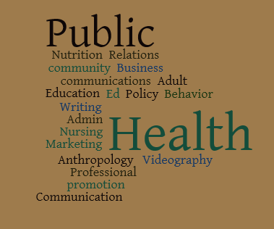
Certifications: |  |  |  | Public Health, Community Development, CHES, MCHES, Registered Dietician, RN, PIO training, Crisis Communications
Specialized Training: |  |  |  | PIO training according to EP plan, variety ICS courses
Salary/hr: |  |  |  | Average Starting Wage: $27.11  Average Top of Scale (not including supervisory pay): $28.16
Other Commentary: |  |  |  | Duties are included with Health Promotion Coordinator position, Deputy Health Officer, same as EPC
Staff covering PIO duties |  |  |  | Average: 2 staff
# media releases per month |  |  |  | Average: 2.8
How disseminate Media information |  |  |  | Email : 29  GOV delivery: 2  Social Media: 25  Website: 265  Other: Broadcast Fax, Print Media, Newspaper, 211 Email Blast, Twitter, staff and partner listservs
Branding Plan or communication policy: |  |  |  | Yes = 17  No = 12
Communication capabilities through in house or contracts |  |  |  | Graphic design = 19  Branding = 9  Advertising = 21  Risk Communication = 20  Digital Communication = 12  Targeted Messaging = 16  Social Marketing Science for Behavior Change Messaging = 10
How does your department evaluate communication strategy |  |  |  | Focus groups =3  Target Audience Surveys = 7  Recording Press Coverage = 13  Surveying New Customers or program recipients = 10
Barriers to communication/PIO activities |  |  |  | Lack of Funding – 17  Lack of time for communication planning = 17  Lack of funding to hire PIO = 16
Staff members of PIO network? |  |  |  | No= 6  Yes =24  No Rep: Bay County, Benzie – Leelanau, Lapper, Mid-Michigan, Midland, Shiawassee

