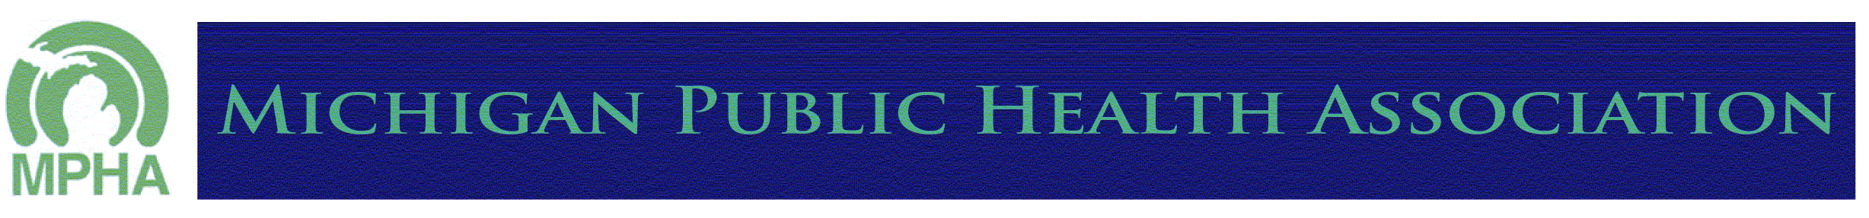
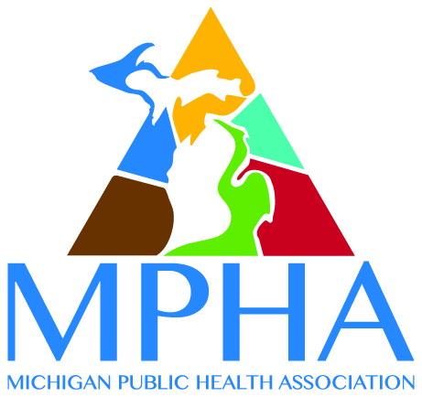

PUBLIC HEALTH NURSING SECTION

Excellence in Public Health Nursing Award

Please share this message to all who may be interested.

The Public Health Nursing Section of the Michigan Public Health Association is seeking nominations for the Excellence in Public Health Nursing Award to be presented at the MPHA-PHN Section Annual Conference on April 16, 2019 in Grand Rapids, MI. Please consider nominating Public Health Nurses and students who are worthy recipients of this award and submit this nomination form today to Lynn McDaniels, McDanieLsL@hotmail.com by January 11, 2019.

Criteria for the award: The nominee must have demonstrated excellence in public health nursing, either in practice, education or research. In addition, the nominee may have demonstrated excellence in leadership, policy development or a creative achievement. The achievement must have led to positive health outcomes for individuals, families, students, and/or communities. The award will be presented at the MPHA-PHN Section Annual Conference, and includes MPHA-PHN Annual Meeting registration and one year of MPHA membership.

Name of Nominee (Last, First, MI):

Home Address (Street, City, State, Zip):

Phone: Email:

Nominee is aware of the nomination (Please indicate) ☐Yes ☐No
Nominee is a member of MPHA and the PHN Section ☐Yes ☐No

Nominee’s current position and employer:

Name of Nominator (nominator does not need to be a member of MPHA or the PHN Section):

Nominator’s current position and employer:

Nominator is a member of MPHA and the PHN Section ☐Yes ☐ No

Nominator’s Address (Street, City, State, Zip):

Phone: Email:

Please attach the following along with this form:

1. A description of how the nominee meets the criteria for the Excellence in Public Health Nursing Award

and

2. A copy of the nominee’s resume or curriculum vitae.

11-7-18

