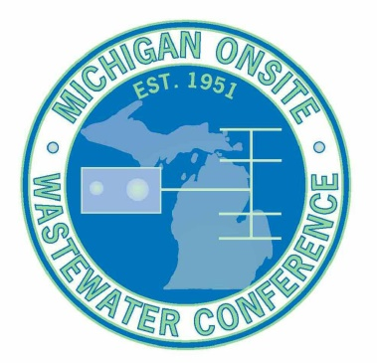
Scholarship Application Form
The Michigan Onsite Wastewater Conference is offering a limited number of scholarships to help those people attend the conference that may otherwise not have access to the funding.
There are two types of scholarships being offered;
- Tuesday only
- Full Conference
What’s covered by the scholarship is the cost of the conference itself. Either $65 for Tuesday or $150 for the full conference. It does not cover the cost of the Hotel, Banquet or the workshop.
Select below which you are applying for;
Tuesday Only
Full Conference
Please briefly describe the reason you are applying for the scholarship and how the education you hope to obtain from attending will help.
←Add your information here, text will wrap.
Submit this form to Joel Kwiatkowski via email to kwiatkowskij@baycounty.net and Karlyn via email to executiveofficer.msta.biz@gmail.com The deadline to submit this form is December 31, 2018
You will be notified by email if you received the scholarship along with a special discount code to use during the registration process. If you are not 100% positive you will be attending the conference please do not apply for this scholarship. It is limited in number and we expect many people to apply.
This is first come first serve.

