



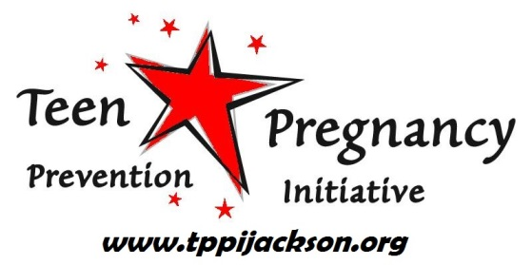
Follow us @ TPPIJackson
Like us @ Jackson Teen Pregnancy
Prevention Initiative
Teen Outreach Program
Jackson County Abstinence Program
HOPE Program
Kelsea Jabkiewicz, Coordinator
Teen Pregnancy Prevention Initiative
Jackson County Health Department, 1715 Lansing Ave., Jackson, MI 49202
(517) 768-2150 (517) 788-4373 (fax) kjabkiewicz@co.jackson.mi.us
How to Contact the Teen Pregnancy Prevention Initiative
Be REAL Summer Program
‘I WISH’ Teen Pregnancy Prevention Video Project
Get REAL Summer Program
TPPI Funded Programs through Multiple Grant Sources
The TPPI can assist with:
- Platform to network through bi-monthly meetings to discuss contributing factors to teen pregnancy prevention and work on strategies together
- Constant communication via e-mail blasts to stay up on teen related issues and volunteer opportunities
- Sex Education Advisory Committee guidance and evidence-bases program expertise
- One-time school presentations and assemblies
- Parent education workshops
- Resources for teen and parents (books, videos, publications)
- Access to our Teen Advisory Council who meets monthly, representing over half of Jackson County high schools, for teen feedback and insight
What can the TPPI help with?
The Teen Pregnancy Prevention Initiative is a collaborative effort featuring an Advisory Committee whose goal is to reduce teen pregnancy in Jackson County. TPPI is funded by the United Way of Jackson County and coordinated by the Jackson County Health Department.
Mission: To reduce the teen pregnancy rate in and address contributing factors for Jackson County’s young people
What is the Jackson County
Teen Pregnancy
Prevention Initiative (TPPI)?

