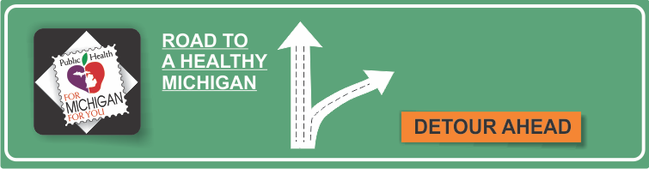[](http://www.countyhealthrankings.org)

* One in five American adults will experience a mental health issue.
* One in ten young people will experience a period of major depression.
* One in twenty-five Americans live with a serious mental illness such as schizophrenia, bipolar disorder, or depression.
* Half of all mental health disorders show first signs before a person turns 14 years old. Three quarters of mental health disorders begin before age 24.
* People with a mental illness are 10 times more likely to be a victim of violent crime than the general population.
* Many factors contribute to development of a mental illness including biological factors, physical illness, brain chemistry, life experiences, trauma, abuse, and family history of mental health problems.
* Mental health and substance abuse disorders are the leading cause of disability worldwide.
* Mental health disorders increase the risk of getting ill from other diseases such as HIV, cardiovascular disease, and diabetes.
* Stigma and discrimination against patients and families prevent people from seeking mental health care.

**Recognizing Public Health Month**

**INSERT LOCAL HEALTH DEPARTMENT INFORMATION HERE**

[www.mentalhealth.gov](http://www.mentalhealth.gov)

[World Health Organization](http://www.who.int/features/factfiles/mental_health/mental_health_facts/en/)

[Mayo Clinic](http://www.mayoclinic.org/diseases-conditions/mental-illness/basics/prevention/con-20033813)

**Information Resources:**

**Mental Health**

# Facts:

There's no sure way to prevent mental illness. However, if you have a mental illness, taking steps to control stress, to increase your resilience and to boost low self-esteem, may help keep your symptoms under control. Follow these steps:

* Pay attention to warning signs. Work with your doctor or therapist to learn what might trigger your symptoms. Make a plan so that you know what to do if symptoms return. Contact your doctor or therapist if you notice any changes in symptoms or how you feel. Consider involving family members or friends to watch for warning signs.
* Get routine medical care. Don't neglect checkups or skip visits to your health care provider, especially if you aren't feeling well. You may have a new health problem that needs to be treated, or you may be experiencing side effects of medication.
* Get help when you need it. Mental health conditions can be harder to treat if you wait until symptoms get bad. Long-term maintenance treatment also may help prevent a relapse of symptoms.
* Take good care of yourself. Sufficient sleep, healthy eating and regular physical activity are important. Try to maintain a regular schedule. Talk to your health care provider if you have trouble sleeping or if you have questions about diet and physical activity.

**Available Services:**

What services are available either locally or statewide?

You can add hyperlinks here too!