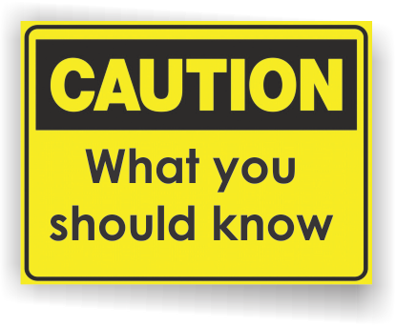[](http://www.countyhealthrankings.org)

**Back To School Month**

* Approximately 3 million children in the United States have hearing loss; 1.3 million of them are under the age of three.
* Hearing loss occurs in 5 out of every 1,000 newborns.
* In the Unites States, two to three children per 1,000 are born with hearing loss in one or both ears.
* More than 90 percent of deaf children are born to hearing parents.
* An estimated 1 in 5 American teens experiences some degree of hearing loss. Eighty percent report that it is due to loud noise.
* Even a mild hearing loss can cause a child to miss as much as 50% of the classroom discussion.
* Undiagnosed and untreated hearing loss can negatively impact a child’s life – significantly affecting his or her development, achievement, social skills, self-esteem and future employment abilities.

**Hearing Loss: Infants & Children**

**INSERT LOCAL HEALTH DEPARTMENT CONTACT INFORMATION**

# Michigan Department of Health & Human Services

***Early Hearing Detection and Intervention (EHDI) Program***

[www.michigan.gov/mdch/0,1607,7-132-2942_4911_21429-55522--,00.html](http://www.michigan.gov/mdch/0,1607,7-132-2942_4911_21429-55522--,00.html)

**Michigan Department of Health & Human Services**

***Hearing Screening***

[www.michigan.gov/mdhhs/0,5885,7-339-73971_4911_4912_6238-260490--,00.html](http://www.michigan.gov/mdhhs/0,5885,7-339-73971_4911_4912_6238-260490--,00.html)

**Centers for Disease Control and Prevention (CDC)  
*Hearing Loss in Children***  
[www.cdc.gov/ncbddd/hearingloss/facts.html](http://www.cdc.gov/ncbddd/hearingloss/facts.html)

**E-Michigan Deaf and Hard of Hearing People**

[www.michdhh.org/index.html](http://www.michdhh.org/index.html)

**Hearing Loss Association of Michigan**

[www.mi-shhh.org/](http://www.mi-shhh.org/)

**Information Resources:**

# Facts:

What services are available either locally or statewide?

You can add hyperlinks here too!

**Hearing Loss**

Hearing loss can vary greatly among children and can be caused by many things.

**Signs of Hearing Loss**

The signs and symptoms of hearing loss are different for each child. Even if a child has passed a hearing screening before, it is important to look for the following signs:

**Infants**

* Does not startle at loud noises.
* Does not turn to the source of a sound after 6 months of age.
* Does not say single words, such as “dada” or “mama” by 1 year of age.
* Turns head when he or she sees you but not if you only call out his or her name. This sometimes is mistaken for not paying attention or just ignoring, but could be the result of hearing loss.
* Seems to hear some sounds but not others.

**Children**

* Speech is delayed and/or not clear.
* Does not follow directions. This sometimes is mistaken for not paying attention or just ignoring, but could be the result of a partial or complete hearing loss.
* Often says, “Huh?”
* Turns the TV volume up too high.

**What causes hearing loss?**

Hearing loss can happen any time during life – from birth to adulthood. Babies born early, who have low birth weight, or who are exposed to infections in the womb might have hearing loss, but this can happen to full-term, normal babies as well. Genetic factors are the cause of hearing loss in about 50% of babies – these babies might have family members who are deaf. Illnesses, injuries, certain medical conditions, and loud noise levels can cause children and adults to lose hearing.

**Prevention**

Some causes of hearing loss can be prevented. Follow these tips:

* Have a healthy pregnancy and prevent infections during pregnancy.
* Make sure your child receives childhood vaccines.
* Keep your infant or child away from loud noises, such as toys, TV, radio, or live music.

**If you or your doctor think your child might have hearing loss, ask that a hearing test be done as soon as possible.**

**Available Services:**