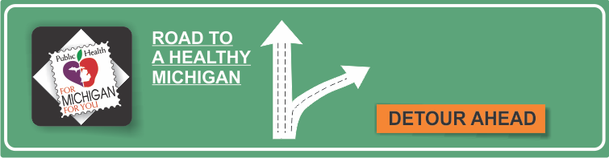[](http://www.countyhealthrankings.org)

**Healthy Beginnings Month**

**Birth Defects**

**{INSERT LOCAL HEALTH DEPARTMENT CONTACT INFO}**

**Michigan Department of Health and Human Services**

**Children’s Special Health Care Services**

[www.michigan.gov/cshcs](http://www.michigan.gov/cshcs)

**CDC/National Center for Birth Defects & Developmental Disabilities**

[www.cdc.gov/ncbddd/](http://www.cdc.gov/ncbddd/)

**March of Dimes**

[www.marchofdimes.com](http://www.marchofdimes.com)

**National Birth Defects Prevention Month is January**

[www.marchofdimes.com/pnhec/4439_1206.asp](http://www.marchofdimes.com/pnhec/4439_1206.asp)

**Family Phone Line**

(800) 359-3722

**Women, Infants, & Children (WIC) Nutrition Program**

[www.michigan.gov/mdch/0,1607,7-132-2942_4910_6329---,00.html](http://www.michigan.gov/mdch/0,1607,7-132-2942_4910_6329---,00.html)

**WIC Line**

(800) 26-BIRTH

* Birth defects are the leading cause of death in the first year of life.
* About 120,000 babies (1 in 33) in the U.S. are born each year with birth defects.
* In Michigan, approximately 8,000 babies are born with birth defects every year.
* There are many different types of birth defects. The most common are heart defects, neural tube defects, and oro-facial clefts.
* The cause is unknown in about 70% of birth defects.

**Information Resources:**

# Facts:

**Available Services:**

**{INSERT LOCAL SERVICES AVAILABLE}**

* Children’s Special Health Care Services
* Family Planning Program
* Maternal & Infant Health Program
* Women, Infants, and Children (WIC) Nutrition Program
* Plan your pregnancy by (1) seeing your health care provider before you get pregnant; (2) getting medical conditions, like obesity, diabetes, or seizures under control before you get pregnant; and (3) taking a vitamin with 400 micrograms of folic acid daily before and during pregnancy.
* Take care of yourself by getting plenty of rest, exercising moderately, eating a well-balanced diet, avoiding contact with chemicals that may harm an unborn baby, avoiding tobacco, alcohol, and street drugs, and talking with your health care provider before taking any over-the-counter drugs.
* If you are planning to get pregnant or you are already pregnant, one of the most important things you can do is see your health care provider. Prenatal care can help to find some problems early in pregnancy so that they can be monitored or treated before birth. Some problems might be avoided with prenatal care.
* Preventing birth defects, and their human and financial costs, is a major goal of Health Departments. Health Departments offer many services to women to prevent birth defects.