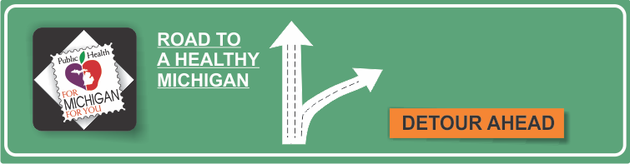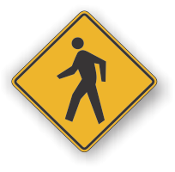[](http://www.countyhealthrankings.org)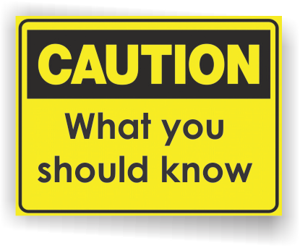

* Your kidneys filter extra water and wastes out of your blood and make urine. Your kidneys also help control blood pressure so that your body can stay healthy. Read more about what your kidneys do. Kidney disease means that the kidneys are damaged and can't filter blood like they should. This damage can cause wastes to build up in the body. It can also cause other problems that can harm your health.
* Major risk factors for kidney disease include diabetes, high blood pressure, family history of kidney failure and being age 60 or older. Additional risk factors include kidney stones, smoking, obesity and cardiovascular disease.
* Diabetes is the leading cause of kidney failure. In fact, 44 percent of people starting dialysis will have kidney failure caused by diabetes.
* Diabetes can damage your kidneys. This damage can happen over many years, without you feeling it. That is why it is so important for people with diabetes to manage their diabetes and get tested for kidney disease. Both type 1 and type 2 diabetes can cause kidney disease.
* Kidney disease often has no symptoms, and it can go undetected until very advanced. But a simple urine test can tell you if you have kidney disease. Remember, it's important to get tested because early detection and treatment can slow or prevent the progression of kidney disease.

**INSERT LOCAL HEALTH DEPARTMENT INFORMATION HERE**

National Kidney Foundation

[www.kidney.org](http://www.kidney.org)

National Kidney Center

[www.nationalkidneycenter.org](http://www.nationalkidneycenter.org)

[National Institute of Diabetes and Digestive and Kidney Diseases](http://www.niddk.nih.gov/health-information/health-communication-programs/nkdep/learn/Pages/learn.aspx)

**Information Resources:**

**Reduce Your Risks Month**

**Kidney Disease**

# Facts:

**Available Services:**

**Tips to keep your kidneys healthy:**

* Keep your blood pressure at the target set by your health care provider. For most people, the blood pressure target is less than 140/90 mm Hg. This can delay or prevent kidney failure.
* If you have diabetes, control your blood glucose level and keep your cholesterol levels in the target range.
* Take medicines the way your provider tells you to. (Important! Certain blood pressure medicines called ACE inhibitors and ARBs may protect your kidneys. Ask your health care provider for more information.)
* Cut back on salt. Aim for less than 2,300 milligrams of sodium each day.
* Choose foods that are healthy for your heart: fresh fruits, fresh or frozen vegetables, whole grains, and low-fat dairy foods.
* Limit your alcohol intake.
* Be more physically active and lose weight if you are overweight.
* If you smoke, take steps to quit. Cigarette smoking can make kidney damage worse.

What services are available either locally or statewide?

Can add hyperlinks here too!