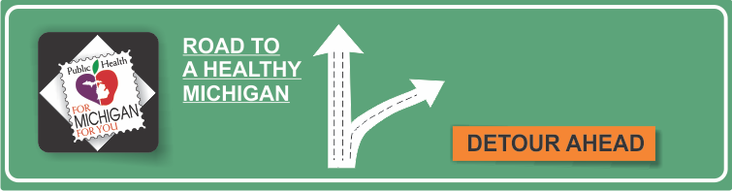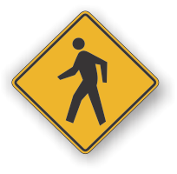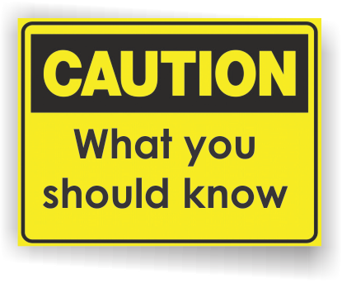[](http://www.countyhealthrankings.org)

**Be Prepared: Protect Your Family and Community Month**

**INSERT LOCAL HEALTH DEPARTMENT CONTACT INFORMATION**

**Centers for Disease Control and Prevention**

***Understanding the Epidemic***

<http://www.cdc.gov/drugoverdose/epidemic/index.html>

**Centers for Disease Control and Prevention**

***Safer, More Effective Pain Management***

<http://www.cdc.gov/drugoverdose/prescribing/index.html>

**National Institute on Drug Abuse**

***Preventing and Recognizing Prescription Drug Abuse***

<https://www.drugabuse.gov/publications/prescription-drugs-abuse-addiction/preventing-recognizing-prescription-drug-abuse>

# Facts:

* Prescription drug abuse is the use of medication without a prescription, in a way other than as prescribed by a provider.
* Every day, 44 people in the U.S. die from overdose of prescription painkillers, and many more become addicted.
* The amount of prescription painkillers dispensed in the U.S. has quadrupled since 1999 to present, and more than 16,000 people in the U.S. died in 2013 alone.
* A big part of the overdose problem results from prescription painkillers called opioids. Opioids can be used to treat moderate to severe pain. The most common drugs involved in prescription overdose deaths include:
  + Hydrocodone (e.g. Vicodin)
  + Oxycodone (e.g. OxyContin)
  + Oxymorphone (e.g. Opana)
  + Methadone (especially when prescribed for pain)

**Prescription Drug Abuse**

**Information Resources:**

**Available Services:**

**Definitions of Abuse and Overdose**

* **Overdose**: When a drug is swallowed, inhaled, injected, or absorbed through the skin in excessive amounts and injures the body. Overdoses are either intentional or unintentional. If the person taking or giving a substance did not mean to hurt themselves or others, then it is unintentional.
* **Abuse:** Continued use of illicit or prescription drugs despite problems from drug use with relationships, work, school, health, or safety. People with substance abuse often experience loss of control and take drugs in larger amounts or for longer time periods than they intended.
* **Naloxone:** A prescription drug that can reverse an opioid or heroin overdose if administered in time.

**Risk Factors for Prescription Painkiller Abuse and Overdose**

People particularly vulnerable to prescription painkiller abuse and overdose have risk factors including:

* Obtaining overlapping prescriptions from multiple providers and pharmacies.
* Taking high daily dosages of prescription painkillers.
* Having mental illness or a history of alcohol or other substance abuse.
* Living in rural areas and having low income.

**Protect yourself and your loved ones from prescription painkiller abuse and overdose death:**

* Talk with your doctor about:
  + The risks of prescription painkillers and other ways to manage your pain.
  + Making a plan on when and how to stop, if a choice is made to use prescription painkillers.
* Use prescription painkillers only as directed by your doctor
* Store prescription painkillers in a safe place and out of reach of others.
* Help prevent misuse and abuse by not selling or sharing prescription painkillers, and by properly disposing of them when you’re finished.

**{INSERT LOCAL SERVICES AVAILABLE}**

RedMed Box Disposal Sites in County/Region

Get help for substance abuse problems at 1-800-662-HELP